Maryland Historical Trust Inventory No. PG: 86B-007

Maryland Inventory of

Historic Properties Form

1. Name of Property (indicate preferred name)
historic Margaret Baden House
other
2. Location
street and number 14909 Croom Road not for publication
city, town Brandywine vicinity
county Prince George's
3. Owner of Property (give names and mailing addresses of all owners)
name Earnest M. & Maureen L. Ingle, Jr.
street and number 14909 Croom Road telephone
city, town Brandywine state MD zip code 20613-7302

4. Location of Legal Description
courthouse, registry of deeds, etc. Prince George's County Courthouse liber 6077 folio 421
city, town Upper Marlboro tax map 158 tax parcel 22 tax ID number 04 0256321 & 04 0256339

5. Primary Location of Additional Data
Contributing Resource in National Register District
Contributing Resource in Local Historic District
Determined Eligible for the National Register/Maryland Register
Determined Ineligible for the National Register/Maryland Register
Recorded by HABS/HAER
Historic Structure Report or Research Report at MHT

X Other: Maryland-National Capital Park and Planning Commission, Prince George's County Planning Department

6. Classification
Category Ownership Current Function Resource Count
district public agriculture landscape Contributing Noncontributing
X building(s) X private commerce/trade recreation/culture 3 1 buildings
structure both defense religion sites
site X domestic social 1 3 structures
object education transportation 1 objects
funerary work in progress 4 5 Total
government unknown
health care vacant/not in use Number of Contributing Resources
industry other: previously listed in the Inventory
3

7. Description Inventory No. PG: 86B-007

Condition

excellent deteriorated
good ruins
fair X altered

Prepare both a one paragraph summary and a comprehensive description of the resource and its various elements as it
exists today.

The Margaret Baden House is located at 14909 Croom Road near Naylor, Maryland. The dwelling is sited to the west of Croom Road (MD 382) at the end of a gravel driveway. Mature trees and shrubs mark the sloping rural lot while a small pond is located at the northern end of the property. Multiple resources are associated with the Margaret Baden House. These include: an in-ground pool with a gazebo north of the dwelling, two barns and a machine shed to the northeast, and further to the northwest, a shed and outbuilding.

Dwelling

The Margaret Baden House was constructed c. 1830 in the Greek Revival style, and altered c. 1970 to reflect the Colonial Revival style. The two-story, three-bay dwelling has a side-hall plan. The wood-frame dwelling is set on a brick foundation and has been clad in aluminum siding. Two interior chimneys pierce the southern-ends of both the east and west slopes of the roof. A side-gabled roof covered with asphalt shingles and featuring overhanging eaves caps the dwelling. A porch is located along the façade (east elevation) as well as the west (rear) elevation. A two-story, three-bay addition has been added to the south (side) elevation of the main block.

The façade (east elevation) of the Margaret Baden House is dominated by a full-façade shed-roofed portico added c. 1970. Set on a brick foundation covered with cement, the portico is supported by fluted hollow-core wood columns set on brick piers. The primary entrance is located in the northern bay and consists of a single-leaf paneled wood door with a denticulated cornice, eight-light transom, and four-light sidelights. The square-edged wood door surround features engaged pilasters and decorative moldings on the sidelight jambs. Fenestration consists of two 6/6 windows on the first story and three 6/6 windows on the second story. The windows are covered with storm-glass windows and feature aluminum-clad surrounds.

The north (side) elevation is fenestrated by a window opening in the foundation wall covered with plywood and a 1/1 vinyl-sash window with 6/6 snap-in muntins and a vinyl-clad surround on the first story. There are no openings on the second story.

The west (rear) elevation of the main block is fenestrated by three 1/1 windows with 6/6 snap-in muntins and aluminum-clad surrounds on the second story. The first story of the west (rear) elevation has a one-story enclosed shed-roofed porch that spans the width of the main block as well as the c. 1930 addition. Based on photographs from a 1985 on-site survey, the porch was enclosed with screens. The porch is now clad in vinyl siding and fenestrated by a large, fixed, single-light window on the north (side) elevation. The west (rear) elevation features a single-leaf paneled wood door with lights in the northern bay flanked by seven large fixed single-light windows to the south. The south (side) elevation features a sliding glass door with multiple-light snap-in muntins.

The south (side) elevation of the main block is fenestrated by a 6/6 window with square-edge wood surround in the eastern end of the first and second stories.

The two-story, three-bay addition located on the south (side) elevation of the main block is set on solid foundation faced in all-stretcher-bond brick foundation. Based on its form and materials, the addition appears to have been constructed during the first half of the twentieth century. The wood-frame addition is clad in aluminum siding with an exterior-end single-shouldered chimney constructed of stretcher-bond brick featuring a corbeled cap. The side-gabled roof has a shed roof extension on the second story of the west end, above the one-story rear porch. Based on its form and materials, this extension appears to have been constructed c. 1970. The roof features overhanging eaves and is covered with asphalt shingles. A porch is located on the façade (east elevation) and appears to have been constructed c. 1970.

The façade (east elevation) of the addition features a single-leaf paneled wood door with lights flanked by 1/1 vinyl-sash windows with 6/6 snap-in muntins and vinyl-clad surrounds on the first story. The second story is fenestrated by three 1/1 vinyl-sash windows with 6/6 snap-in muntins and vinyl-clad surrounds. The one-story, three-bay shed-roof porch, covered with asphalt shingles, is supported by turned and chamfered wood posts.

The south (side) elevation of the addition features a louvered vent located in the gable end with a vinyl-clad surround.

The west (rear) elevation of the extension is fenestrated by two 1/1 windows with 6/6 snap-in muntins and vinyl-clad surrounds on the second story of the addition.

The north (side) elevation of the extension is fenestrated by an octagonal window with a vinyl-clad surround on the second story of the addition.

The interior of the Margaret Baden House was not accessible at the time of the 2007 on-site survey.

Barn (1)

Barn (1) is located northeast of the dwelling. Based on its form and materials, the barn appears to date from c. 1950. Set on a concrete-block foundation, this board-and-batten structure is capped by a steeply pitched front-gabled roof covered with standing-seam metal. The roof features exposed rafter tails and overhanging eaves. Fenestration on the façade (west elevation) consists of a centrally located metal roll-up door topped by a large fixed single-light metal-sash window. The south (side) elevation features a single-leaf wood door.

The interior of Barn (1) was not accessible at the time of the 2007 on-site survey.

Barn (2)

Barn (2) is located to the north of Barn (1) and is contemporaneous in date of construction. Set on a concrete-block foundation, this board-and-batten structure is capped by a steeply pitched front-gabled roof covered with standing-seam metal. The roof features overhanging eaves. Fenestration on the façade (west elevation) consists of a single-leaf paneled wood door with square-edged surround flanked to the north by a fixed single-light window with a square-edge wood surround. Fenestration on the south (side) and north (side) elevations consist of a sliding two-light metal-sash window.

The interior of Barn (2) was not accessible at the time of the 2007 on-site survey.

Shed (1)

Located to the north of the dwelling and west of Barn (2) is a one-story wood- and metal-frame shed clad in vertical corrugated metal sheets. Based on its materials, the structure appears to have been constructed c. 1970. Capped by a shed roof covered with corrugated metal sheets, Shed (1) features three open bays on the façade (south elevation).

The interior of Shed (1) was not accessible at the time of the 2007 on-site survey.

Shed (2)

Shed (2) is located to the northwest of the dwelling, beyond the in-ground pool. Based on its materials, the structure appears to have been constructed c. 1970. Set on a concrete foundation, the one-story metal-frame structure is clad in corrugated metal sheets and capped by a shed roof covered with corrugated metal sheets.

The interior of Shed (2) was not accessible at the time of the 2007 on-site survey.

Well

Located west, adjacent to the dwelling, is a well. Based on its form and materials, the well appears to have been constructed c. 1950. The well is set on a poured concrete foundation and features a metal water pump.

It was not ascertained whether the well was functional at the time of the 2007 on-site survey.

Outbuilding

A one-story outbuilding covered with plywood is located to the northwest of Shed (2). Based on its form and materials, the outbuilding appears to have been constructed c. 1980. The façade (southeast elevation) consists of a single-leaf wood door with lights. Fenestration of the southwest (side) elevation consists of a 1/1 window with vinyl-clad surround.

The interior of the outbuilding was not accessible at the time of the 2007 on-site survey.

Pool

An in-ground pool is located to the north of the dwelling. Based on its form and materials, the pool appears to have been constructed c. 1980. The rectangular pool, running north-south, is complimented by a poured-concrete deck and surrounded by a chain-link fence. A gazebo is located on the pool decking.

Gazebo

A prefabricated gazebo is located in the southwest corner of the pool deck. Based on its materials, it appears the gazebo was constructed c. 1980. The octangular wood-frame structure features decorative scrollwork and a ventilator at the top of the pyramidal roof.

Integrity

The Margaret Baden House retains a low level of integrity. The dwelling’s integrity of design, materials, and workmanship are compromised due to the replacement of the original windows and exterior cladding, the enclosing of the east (rear) elevation porch, the construction of a full-facade portico, and multiple large additions to the south (side) elevation. These alterations are not historically sensitive to the architectural style of the Margaret Baden House. The dwelling’s integrity of setting is moderate due to the recent construction dates of the secondary resources. The Margaret Baden House retains its integrity of location, sited near a well traveled road in Prince George’s County. The dwelling’s integrity of association and feeling are low due to numerous alterations to the dwelling and the addition of several non-historic resources.

Barn (1) and Barn (2) retain a moderate level of integrity. The structure’s integrity of design, materials, and workmanship are affected but not compromised due to the poor condition of key architectural elements. The barns, associated with a non-operating agricultural property, have lost their integrity of association and feeling, though retain their integrity of location. The integrity of setting is also diminished due to the introduction of several non-historic resources on the property.

The well retains a moderate level of integrity. Its integrity of design, materials, workmanship, and location are retained due to its current condition and original location. The integrity of setting, association, and feeling are compromised though due to the alterations and additions to the dwelling.

Shed (1), Shed (2), the Outbuilding, the Pool, and the Gazebo are non-contributing resources due to their recent construction dates.

Overall, the Margaret Baden House and associated resources retain a low level of integrity.
8. Significance Inventory No. PG: 86B-007
Period Areas of Significance Check and justify below

1600-1699 agriculture economics health/medicine performing arts
1700-1799 archeology education industry philosophy
X 1800-1899 X architecture engineering invention politics/government
1900-1999 art entertainment/ landscape architecture religion
2000- commerce recreation law science
communications ethnic heritage literature social history
community planning exploration/ maritime history transportation
conservation settlement military X other: Local History

Specific dates c. 1830 Architect/Builder Unknown

Construction dates c.1830, c. 1925, c.1970, c.1990

Evaluation for:

National Register Maryland Register not evaluated

Prepare a one-paragraph summary statement of significance addressing applicable criteria, followed by a narrative discussion of the history of the resource and its context. (For compliance projects, complete evaluation on a DOE Form – see manual.)

Statement of Significance

The Margaret Baden House, located at 14909 Croom Road near Naylor, Maryland, is an example of an early-nineteenth-century plantation house constructed in Prince George’s County. The modest two-story, three-bay main block was constructed in the Greek-Revival style with a side-hall plan. The house now evokes the Colonial-Revival style based on its full-façade portico. The Margaret Baden House stands out as a high-style example of an early-nineteenth-century farmhouse, less common than the typical vernacular I-house form. As a result of numerous alterations and additions, including the portico and side addition, the Margaret Baden House does not retain sufficient integrity of convey its significance as an early-nineteenth-century Greek-Revival-style farmhouse.

Historic Context

The Margaret Baden House is located near Naylor, a community in the southeastern portion of Prince George’s County. Changes to the county’s economy that occurred from the end of the Civil War (1861-1865) to the turn of the twentieth century are still visible in the landscape of southern Prince George’s County. During this period, agriculture, while remaining the dominant form of livelihood, changed from a series of large plantations to numerous small farming operations. Freed blacks operated a large number of these small farms, but during the Reconstruction period (1865-1917), both white and black newcomers to the county purchased the majority of small farms. William Harvey conveyed the parcel of land, known as the Exchange, to Margaret Baden in 1828 for $200.

Margaret Baden, born approximately 1797, is listed as a planter, without a husband, and having real estate worth $1,000 at the time of the 1860 U.S. Federal Census. The house appears on Martenet’s 1861 Map of Prince George’s County, supporting the building’s c. 1830 construction date. Baden would continue to own the property until the end of the Civil War in 1865, when she conveyed it to her daughter, Margaretta V. Baden. Margaretta Baden would own the property until bequeathing it to her brother, Jeremiah Thomas Baden, in 1882.

Jeremiah Baden is listed as a farmer at the time of the 1880 U.S. Federal Census. Born c. 1818, Baden and his wife Isabella had six children, two of whom worked on the family farm. As stipulated in the Will of Margaretta V. Baden, the property is conveyed to Jeremiah Baden’s three daughters, Sarah Margaret, Ella Williams, and Mary Emma following his death in 1894.

The three daughters convey the property to Sarah Margaret Baden’s husband, William M. Baden in 1894. Due to the common last name, it is possible Sarah Margaret Baden and William M. Baden were related. William M. Baden, born approximately 1863, is listed as a general farmer at the time of the 1910 U.S. Federal Census. At that time, Baden was farming 41 acres, as he acquired 34 adjacent acres from Robert E. Baden in 1894 for $150.

William M. Baden died in 1924, conveying his property to his executer, Elmer L. Baden, in trust, with one-half the income to go to his wife, Mary L. Baden. The Will stipulated that at her death the land was to be sold and the proceeds divided equally among his three children, Elmer L. Baden, Mary I. Blandford, and Grace E. Taylor. Elmer L. Baden is listed as a farmer at the time of the 1930 U.S. Federal Census.

Elmer L. Baden received the property in 1949 for $3,000. When he died in 1965 he bequeathed his two children William K. Baden and Louise B. Sansbury the property. The two children and their respective families owned the property until 1967, when it was purchased by Donald Franklin Greenfield, Sr. Greenfield was responsible for the alterations to the rear of the Margaret Baden House.

The current owners, Earnest M. and Maureen L. Ingle, purchased the property in 1985 from Donald F. Greenfield, Sr. No commercial farming operations were not taking place at the time of the 2007 on-site survey.

9. Major Bibliographical References Inventory No. PG: 86B-007
1860, 1880, 1310, and 1930 U.S. Federal Census (Population Schedule). Online: The Generations Network, Inc., 2007.
Subscription database. Digital scan of original records in the National Archives, Washington, DC. http://www.ancestry.com.
King, Marina. “Margaret Baden House” (PG: 86B-007), Maryland Historical Trust State Historic Sites Inventory Form, 1985.
Martenet, Simon J. Martenet's Map of Prince George’s County, Maryland. Baltimore: Simon J. Martenet, 1861.
Maryland-National Capital Park and Planning Commission and Prince George’s County Planning Department, Historic Sites and Districts Plan, 1992.
Prince George’s County Land Records.
10. Geographical Data

Acreage of surveyed property 44.1545
Acreage of historical setting 7
Quadrangle name Lower Marlboro Quadrangle scale: 1:24,000

Verbal boundary description and justification
The Margaret Baden House is located on a 44.1545-acre parcel. Croom Road borders the property to the east while agricultural fields and forest surround the property to the north, south, and west. The dwelling has been associated with Parcel 22 as noted on Tax Map 158 since its construction.

11. Form Prepared by

name/title Paul Weishar, Architectural Historian
organization EHT Traceries, Incorporated date January 2008
street & number 1121 Fifth Street, NW telephone 202.393.1199
city or town Washington state D.C.

The Maryland Inventory of Historic Properties was officially created by an Act of the Maryland Legislature to be found in the Annotated Code of Maryland, Article 41, Section 181 KA,
1974 supplement.

The survey and inventory are being prepared for information and record purposes only
and do not constitute any infringement of individual property rights.

return to: Maryland Historical Trust
Maryland Department of Planning
100 Community Place
Crownsville, MD 21032-2023
410-514-7600

Chain of Title
Prince George’s County Land Records

Deed AB 5:246 William Harvey to Margaret Baden (7 acres, known as the Exchange).
August 13, 1828

Deed 3:315 Margaret Baden to Margaretta V. Baden.
December 9, 1865

Will WAJ Jr. 1:266 Estate of Margaretta V. Baden to Jeremiah Thomas Baden. When Jeremiah dies, the September 13, 1882 property descended to his three daughters: Sarah Margaret Baden, Ella Williams
Baden, and Mary Emma Baden in equal shares.

Deed JWB 27:666 Sarah Margaret Baden, Ella Williams Baden, and Mary Emma Baden to William M.
January 23, 1894 Baden, husband of Sarah Margaret Baden.

Deed JWB 29:517 Robert E. Baden to William M. Baden (34 acres).
June 18, 1894

Will WTD 1:50 Estate of William M. Baden to Elmer L. Baden, executor. One-half of income to his September 24, 1924 wife Mary L. Baden and at her death the property sold and the proceeds divided
equally amongst his three children: Elmer L. Baden, Mary I. Blandford, and Grace E. Taylor.

Deed 1101:7 Mary I. and Samuel M. Blandford, Grace E. and James W. Rawlings, and Elmer L. February 12, 1949 Baden, trustee, to Elmer L. Baden.

Will WDA 14:873 Estate of Elmer Laroche Baden to his two children: William K. Baden and Louise B. March 26, 1965 Sansbury.

Deed 3542:858 William K. and Elizabeth B. Baden, and Louise B. and John R. Sansbury to Donald December 8, 1967 Franklin Greenfield, Sr.

Deed 6077:421 Donald Franklin Sr. to Earnest M. and Maureen L. Ingle.
April 2, 1985

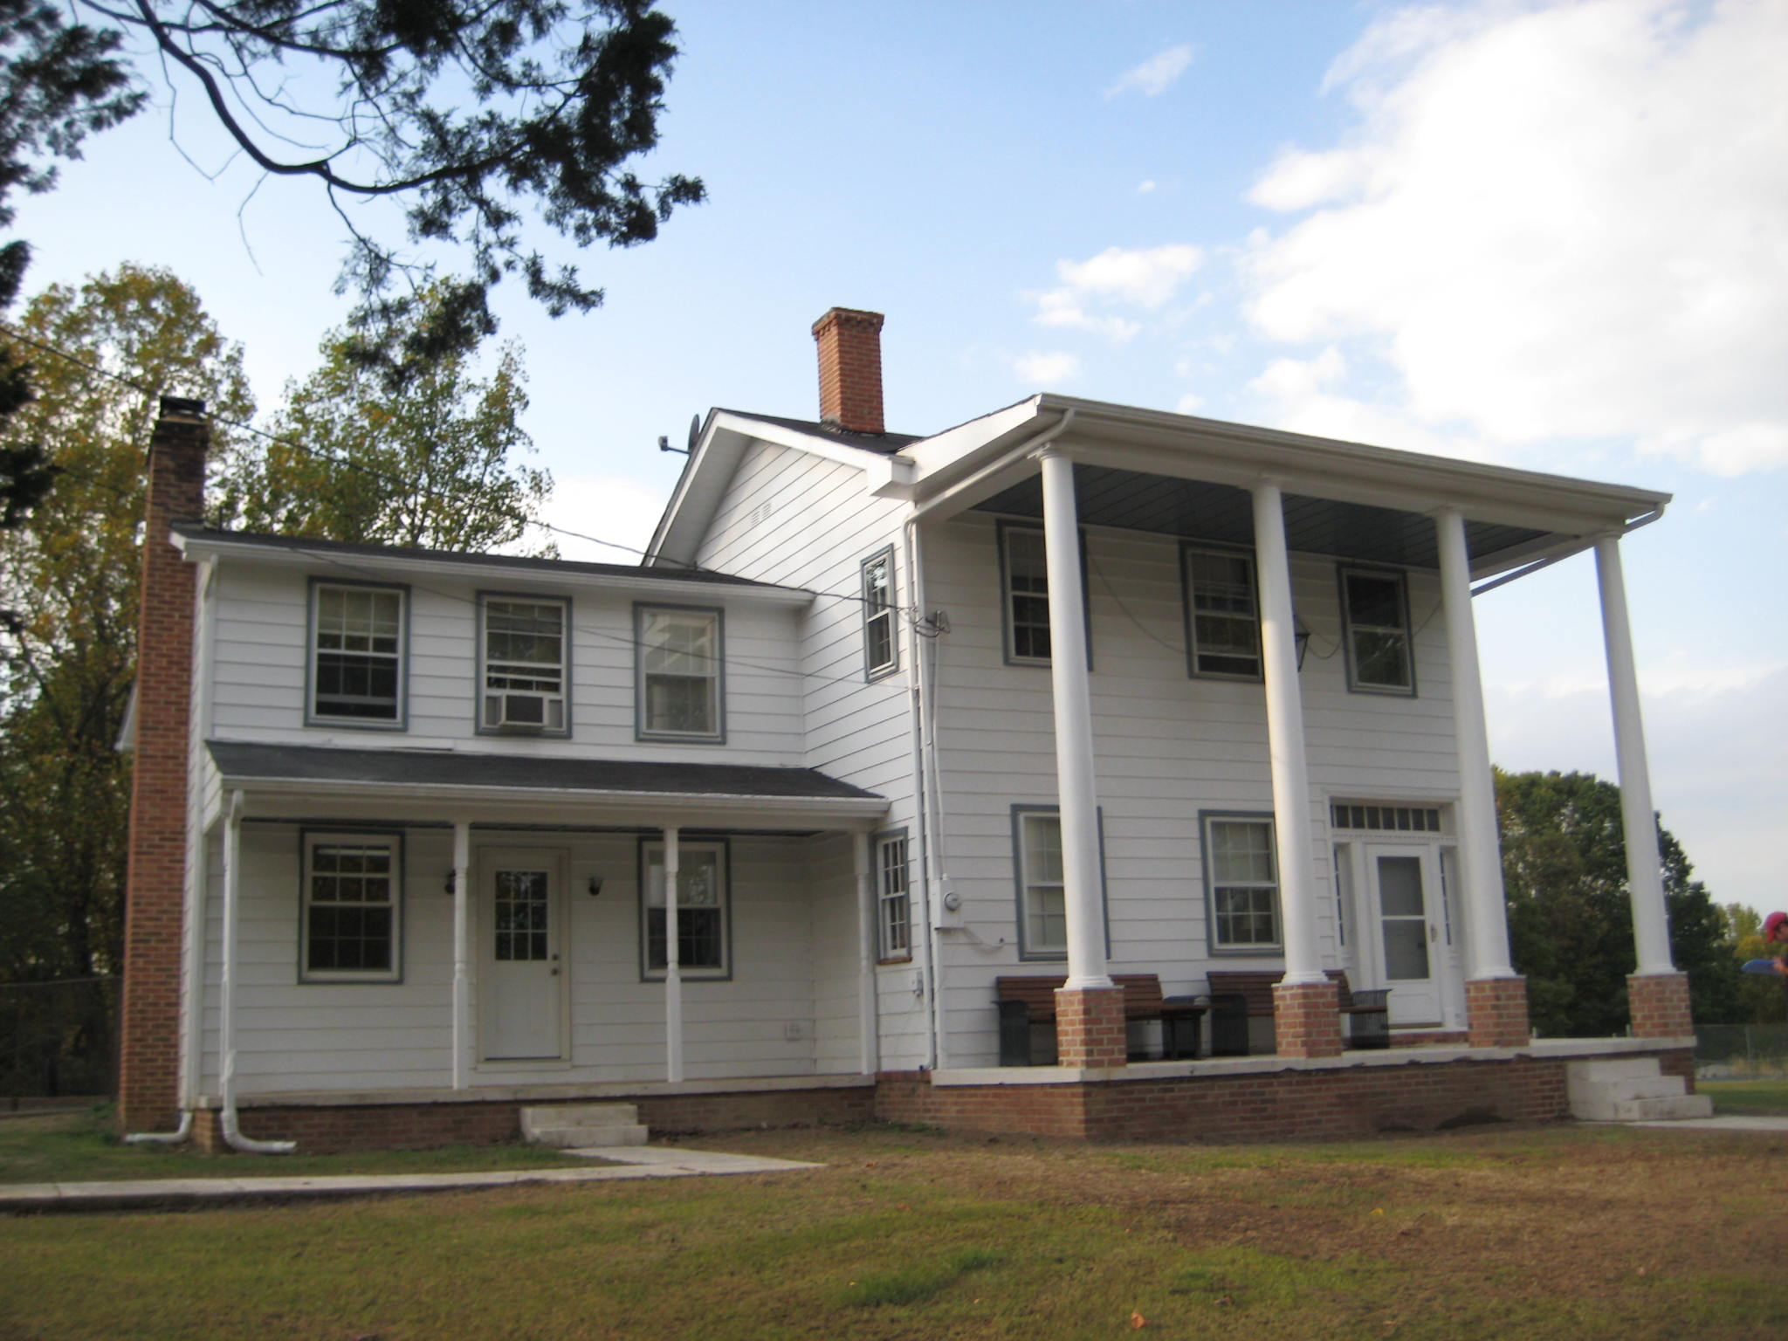

Photo: Margaret Baden House, view of the façade (east elevation), looking west. (November 2007)

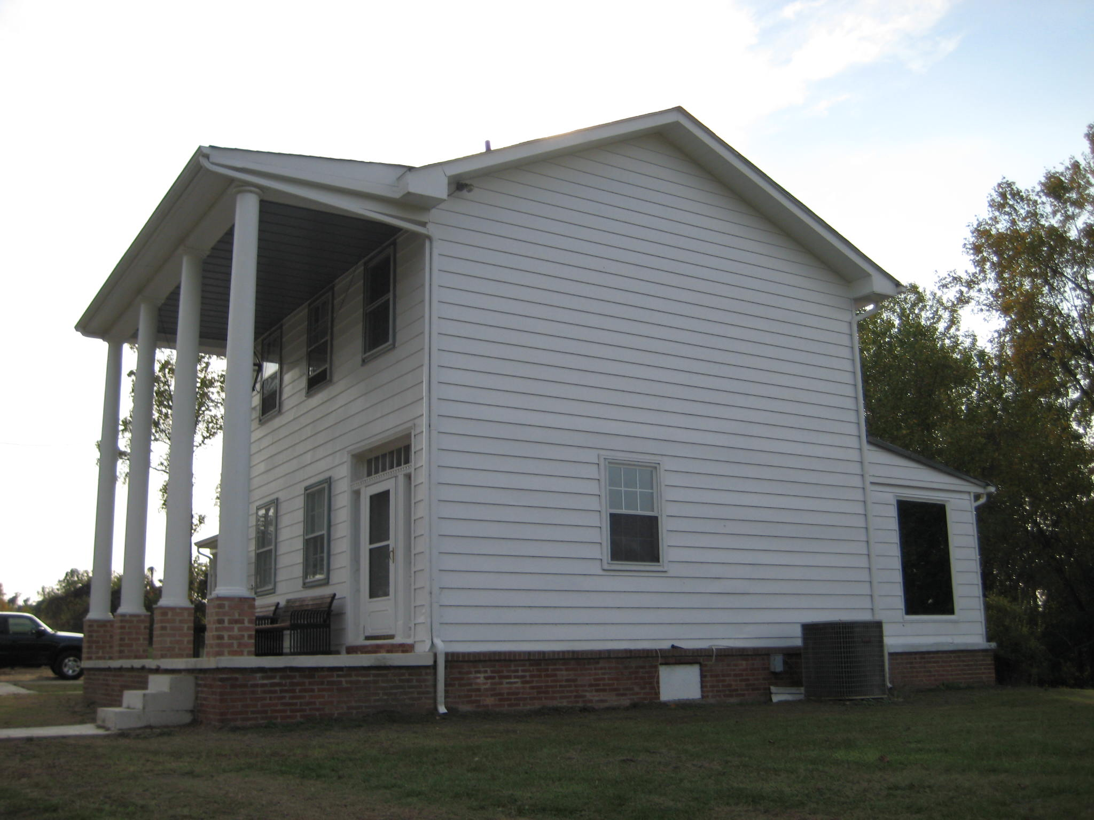

Photo: Margaret Baden House, view of the north (side) elevation, looking southwest. (November 2007)

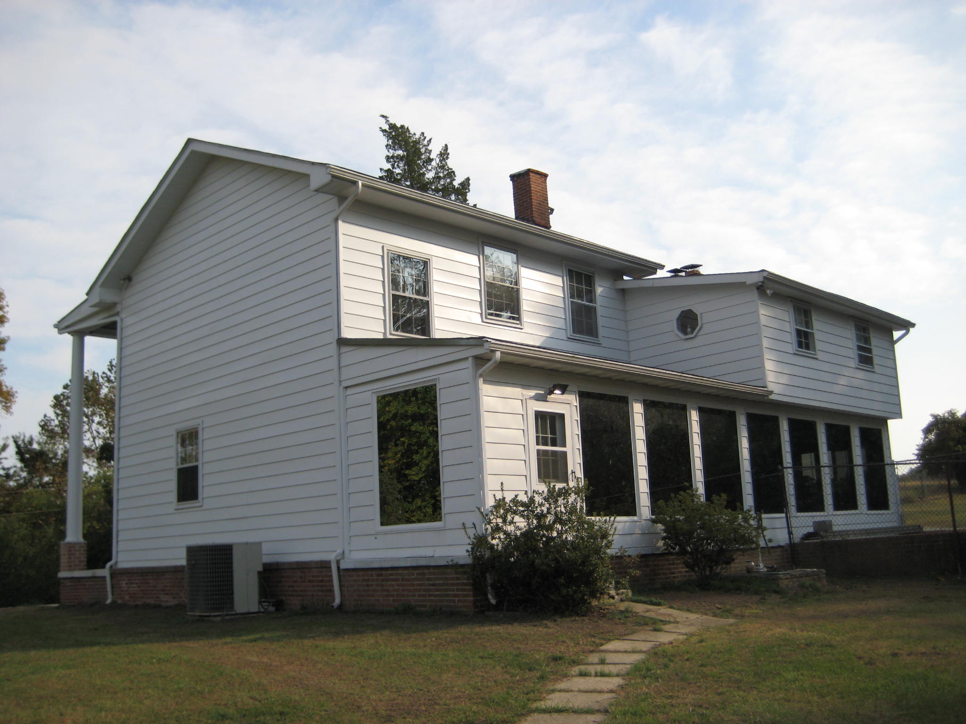

Photo: Margaret Baden House, view of the west (rear) elevation, looking southeast. (November 2007)

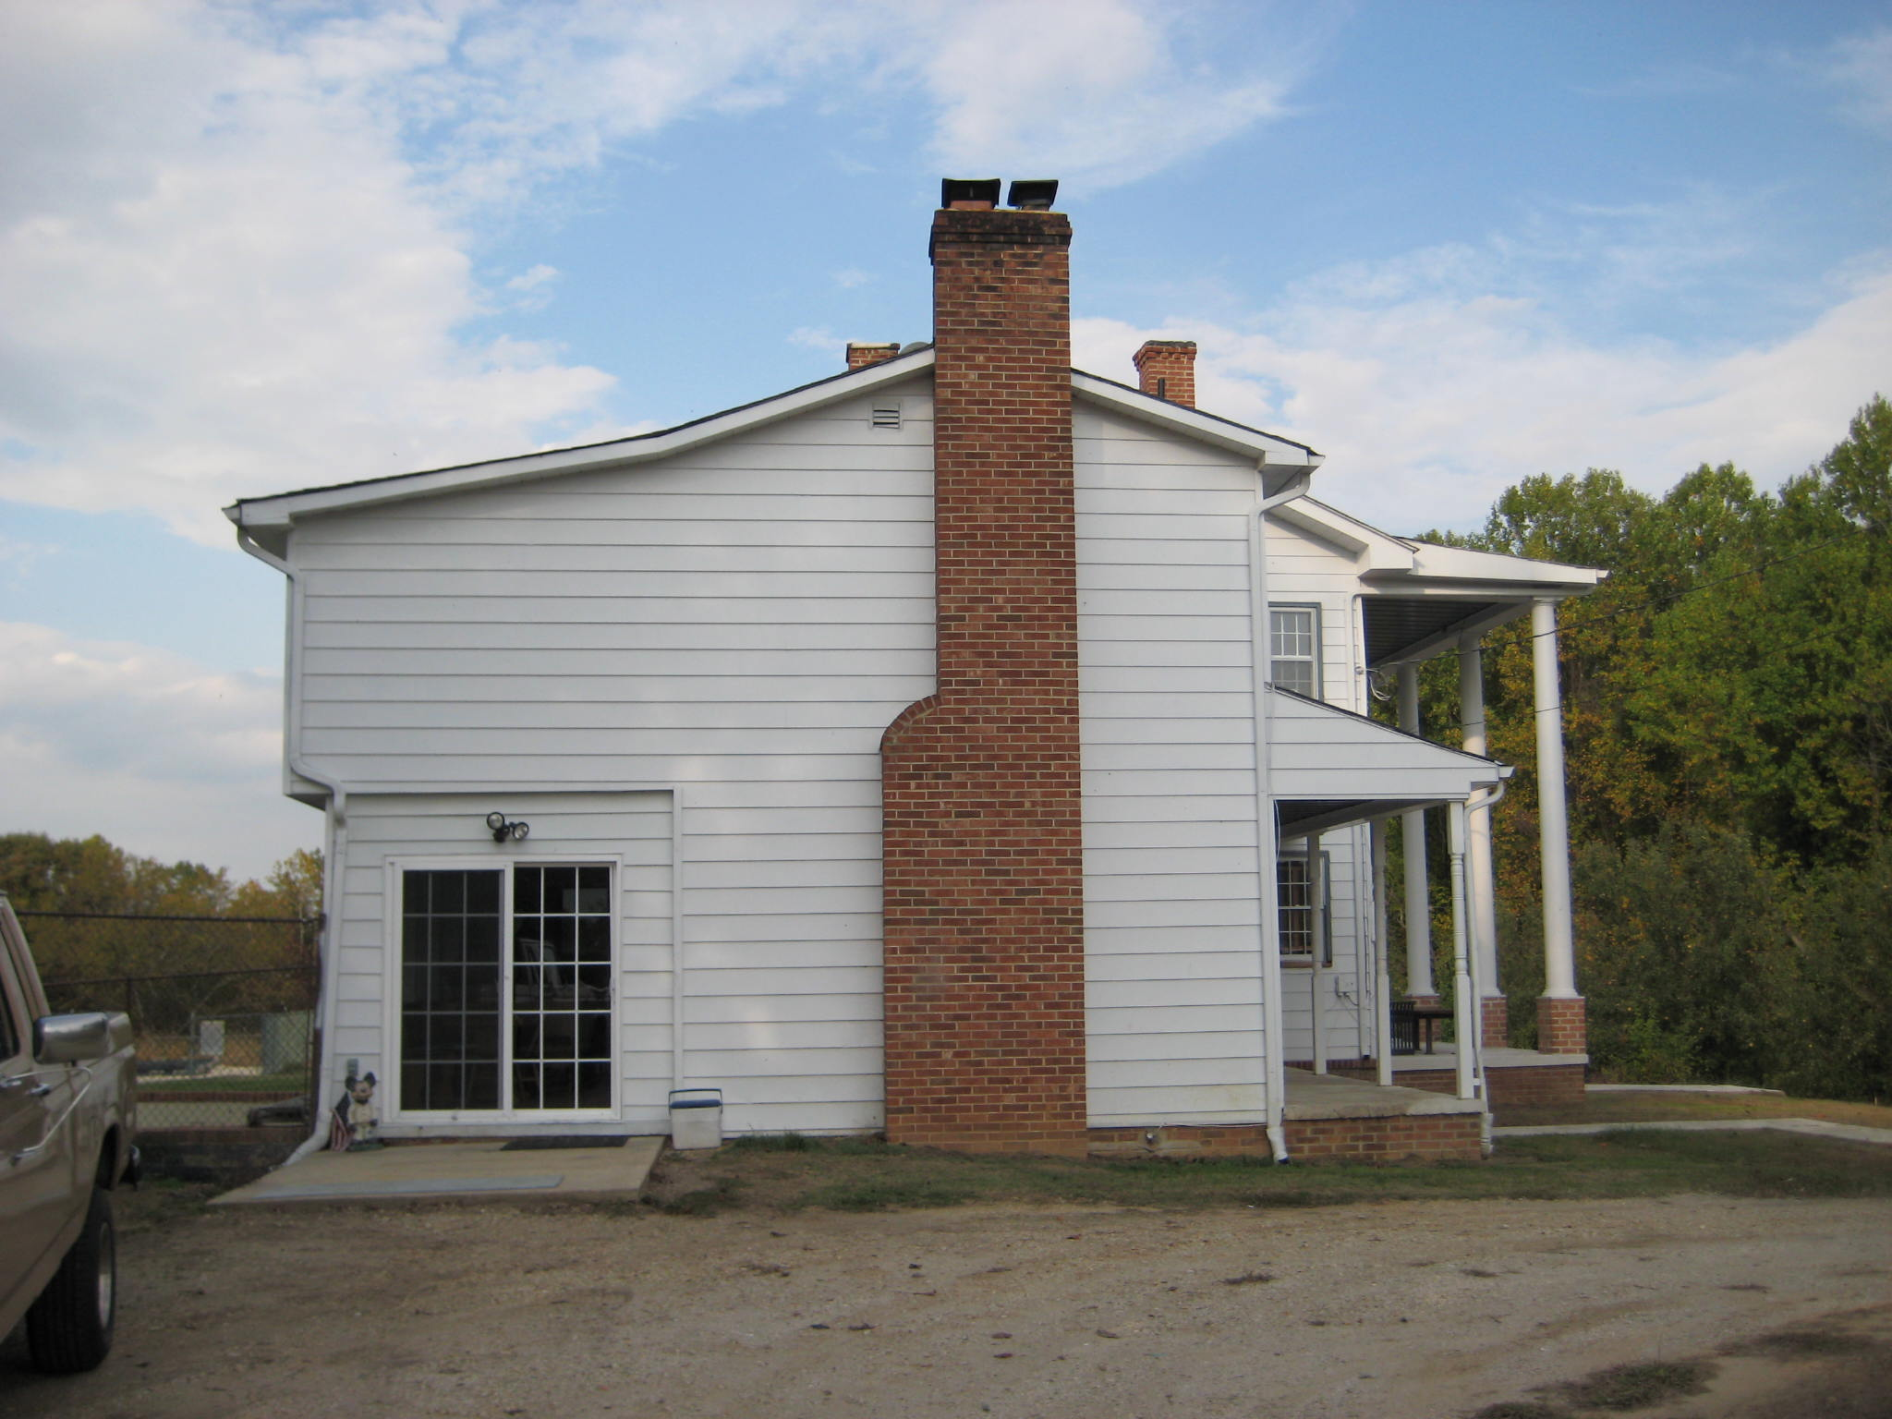

Photo: Margaret Baden House, view of the south (side) elevation, looking north. (November 2007)

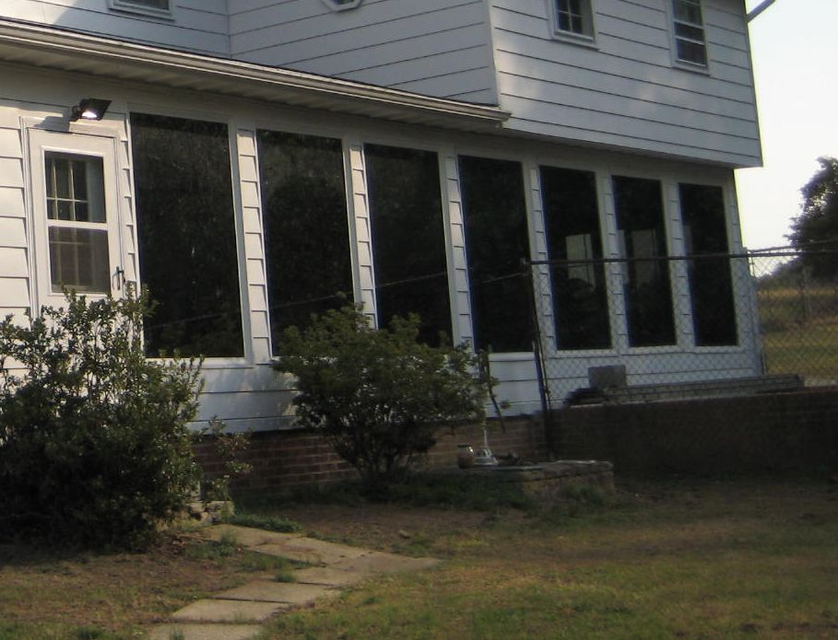

Photo: Well, view looking southeast. (November 2007)

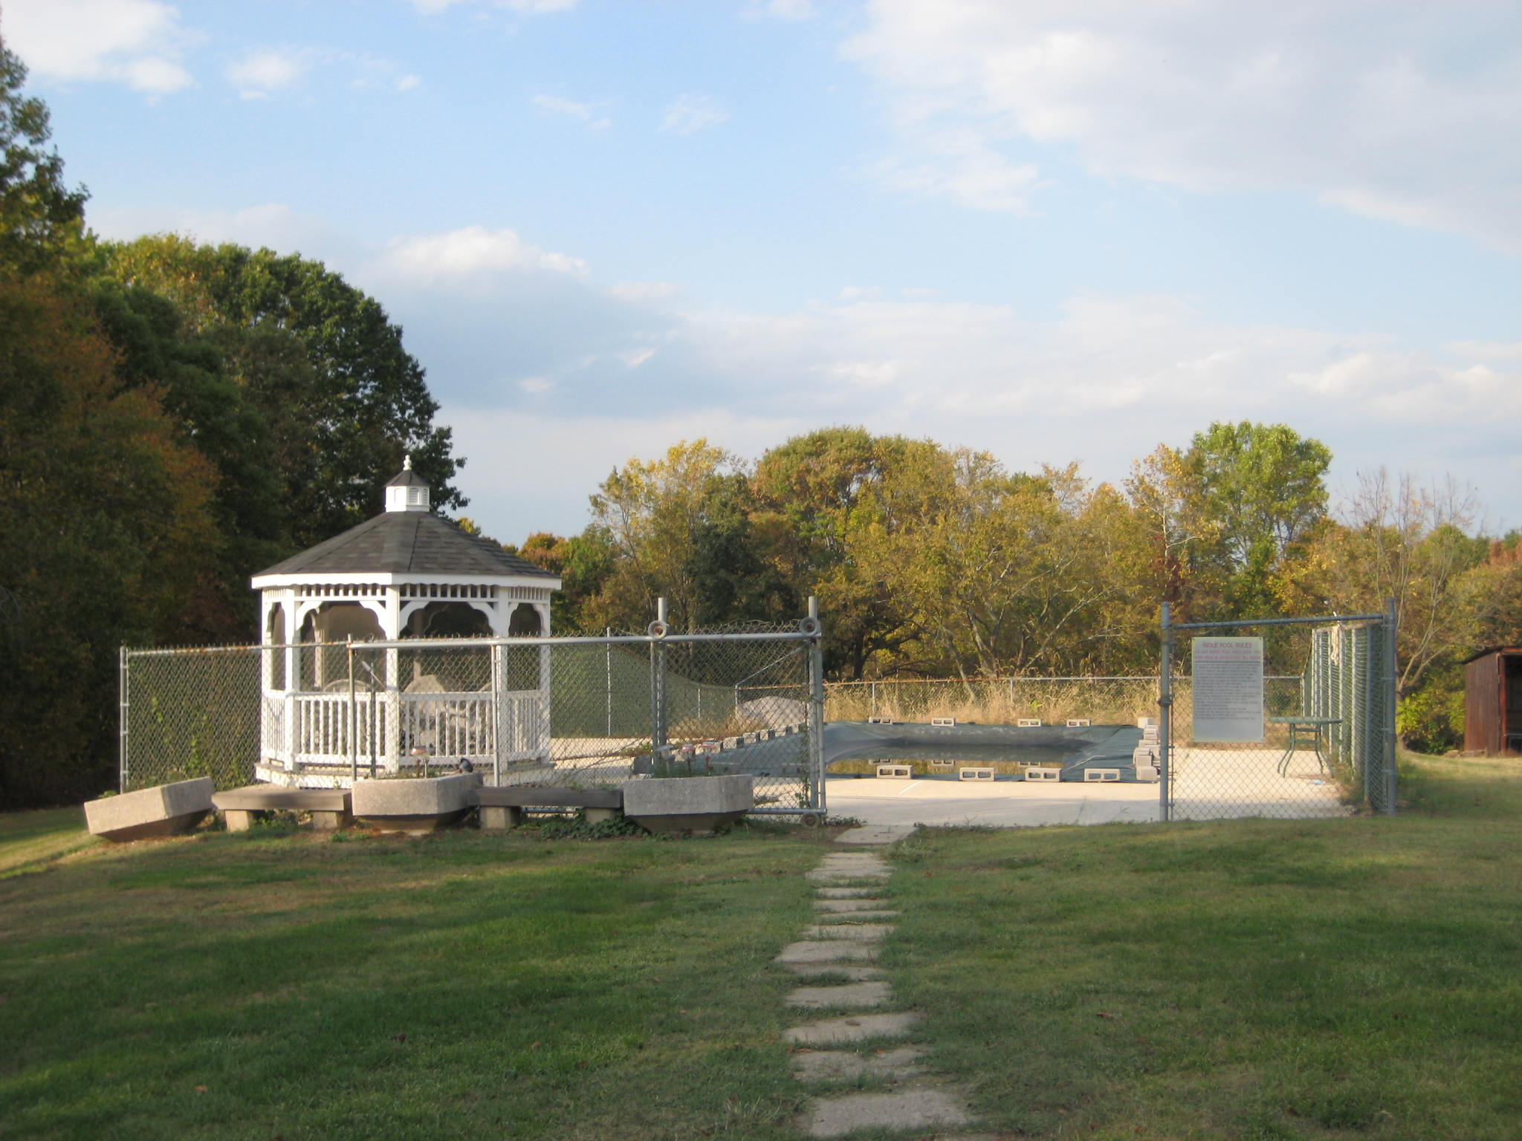

Photo: Gazebo and Pool, viewed looking north. (November 2007)

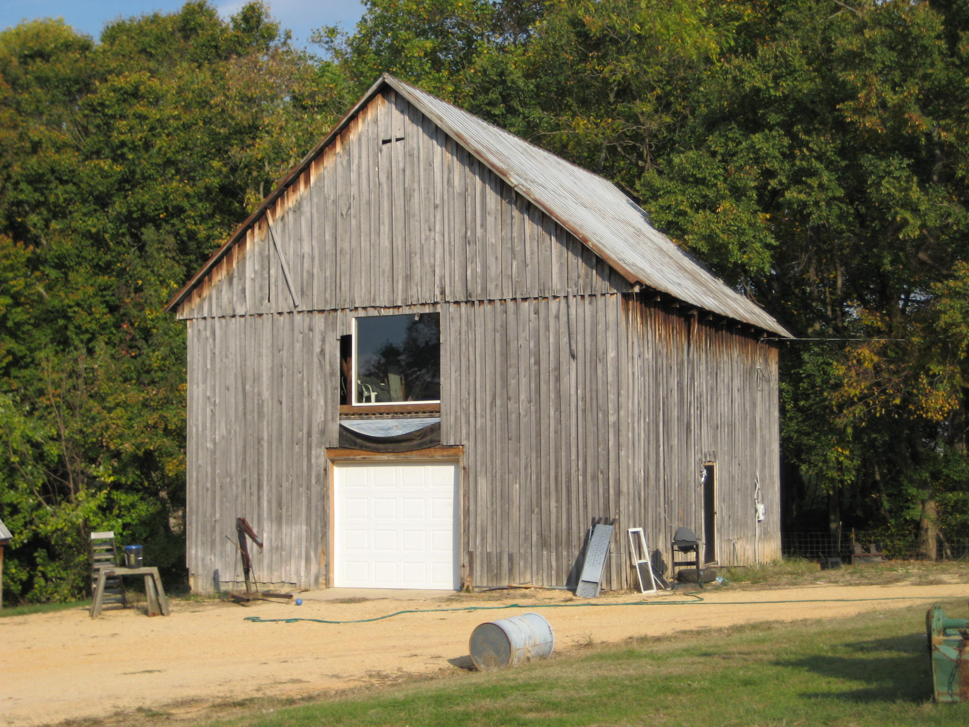

Photo: Barn (1), view of the façade (west elevation), looking east. (November 2007)

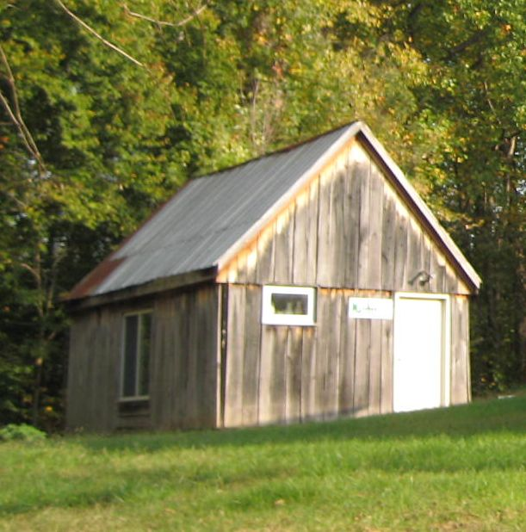

Photo: Barn (2), view of the façade (west elevation), looking southeast. (November 2007)

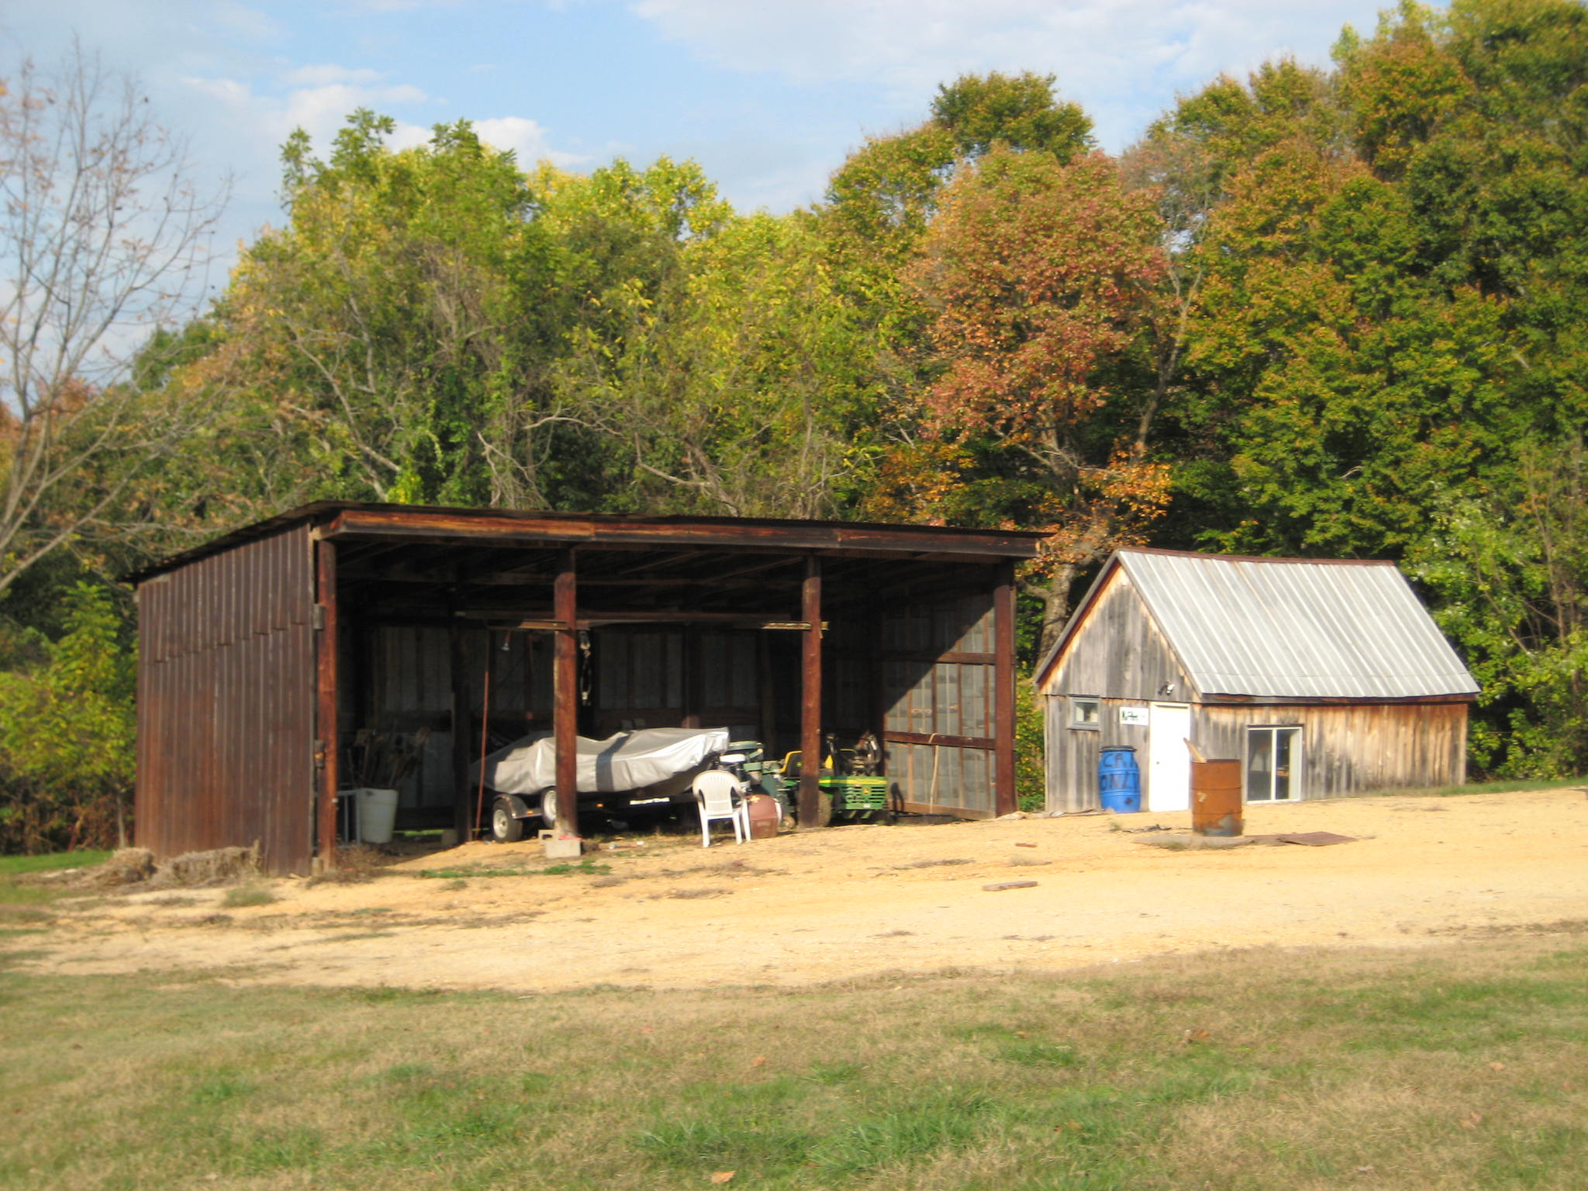

Photo: Shed (1), view of the façade (south elevation), looking northeast. (November 2007)

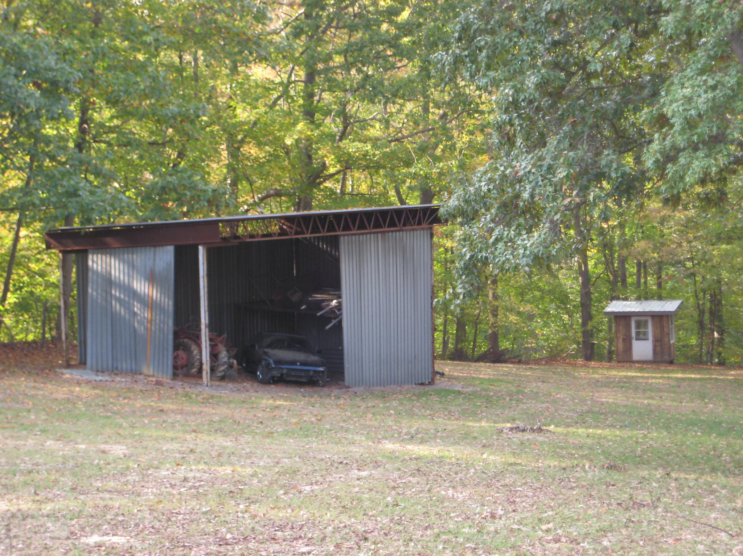

Photo: Shed (2) and Outbuilding, view of the façade (east elevation), looking west. (November 2007)

Marina King, “Margaret Baden House,” (PG: 86B-7), Maryland Historical Trust State Historic Sites Inventory Form (1985), 8:1.
Maryland-National Capital Park and Planning Commission and Prince George’s County Planning Department, Historic Sites and Districts Plan (1992), B-4.
William Harvey to Margaret Baden, Prince George’s County Land Records, AB 5:246.
1860 U.S. Federal Census, District 4, Prince Georges, Maryland, Series M653, Roll 478, Page 95, Image 587, Margaret Baden.
Simon J. Martenet, “Atlas of Prince George’s County, Maryland, 1861,” Adapted from Martenet’s Map of Prince George’s County, Maryland (Baltimore: Simon J. Martenet C.E., 1861).
Margaret Baden to Margaretta Baden, Prince George’s County Land Records, FS 3:315.
Margaretta V. Baden to Jeremiah Thomas Baden, Prince George’s County Land Records, WAJ Jr. 1:266.
1880 U.S. Federal Census, Nottingham, Prince Georges, Maryland, Series T9, Roll 513, Family History Film 1254513, Page 94.1000, Enumeration District 124, Image 0191, Jeremiah Thomas Baden.
Margaretta V. Baden to Jeremiah Thomas Baden, Prince George’s County Land Records, WAJ Jr. 1:266.
Sarah Margaret, Ella Williams, and Mary Emma to William M. Baden, Prince George’s County Land Records, JWB 27:666.
1910 U.S. Federal Census, Nottingham, Prince George's, Maryland, Series T624, Roll 567, Page 11B, Enumeration District 63, Image 167, William M. Baden.
Robert E. Baden to William M. Baden, Prince George’s County Land Records, JWB 29:517.
Will of William M. Baden, Prince George’s County Land Records, WTD 1:50.
1930 U.S. Federal Census, Nottingham, Prince George's, Maryland, Roll 877, Page 7A, Enumeration District 10, Image 760.0.
Mary I. and Samuel M. Blandford, Grace E. and James W. Rawlings, and Elmer L. Baden, trustee, to Elmer L. Baden, Prince George’s County Land Records, 1101:7.
Will of Elmer Laroche Baden to William K. Baden and Louise B. Sansbury, Prince George’s County Land Records, WDA 14:873.
Donald Franklin Greenfield, Sr. to Earnest M. and Maureen L. Ingle, Prince George’s County Land Records, NLP 3542:858.

